Project

Contents

1.Simple Exponential Smoothing 3

1.1:- Forecasts from Simple Exponential Smoothing 5

2.Double Exponential Smoothing:- 7

2. Forecasts from Double Exponential Smoothing 8

3.Winter’s Exponential Smoothing:- 9

3.1:- Forecasts from Winter’s Exponential Smoothing 11

4.AR Model:- 11

5.MA Models: 12

6.ARMA Model 13

7.Overall Decision: 14

8.Fit the AR(4) model:- 14

8.1Forecasting using AR(4) model:- 15

9.MA(4) model:- 16

9.1Forecasting using MA model:- 17

10.ARIMA(1,1,0) Model:- 17

10.1Forecasting using ARIMA model:- 18

11.SARMA (p, q)(P ,Q)12: 19

12.Fit the SARMA(1,1)(1,1)12 Model:- 19

12.1Forecasting using SARMA Model:- 20

# 

# 1.Simple Exponential Smoothing

If you have a time series that can be described using an additive model with constant level and no seasonality, you can use simple exponential smoothing to make short-term forecasts.

The simple exponential smoothing method provides a way of estimating the level at the current time point. Smoothing is controlled by the parameter alpha; for the estimate of the level at the current time point. The value of alpha; lies between 0 and 1. Values of alpha that are close to 0 mean that little weight is placed on the most recent observations when making forecasts of future values. Simple Exponential Smoothing use only when time series is stationary.

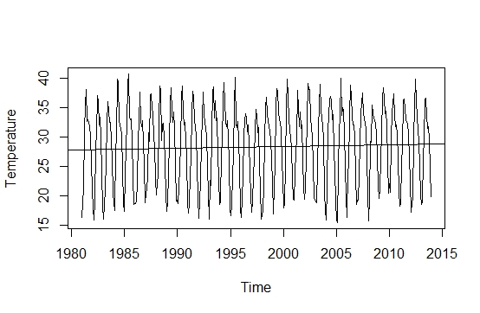**Graph_1:- Stationary**

Above graph shows that our time series data is stationary over time with constant mean and variance.

To make forecasts using simple exponential smoothing in R, we can fit a simple exponential smoothing predictive model using the “HoltWinters()” function in R. To use HoltWinters() for simple exponential smoothing, we need to set the parameters beta=FALSE and gamma=FALSE in the HoltWinters() function (the beta and gamma parameters are used for Holt’s exponential smoothing, or Holt-Winters exponential smoothing).

.

**HoltWinters Function Results:-**

|  |  |  |  |
| --- | --- | --- | --- |
| Smoothing parameters | Alpha | Beta | Gamma |
| 0.9999 | 0 | 0 |

Coefficients: [,1]

a 19.90031

The output of HoltWinters() tells us that the estimated value of the alpha parameter is about 0.999. This is very close to one, telling us that ALPHA equal 1 sets the current smoothed point to the current point (i.e., the smoothed series is the original series). The closer ALPHA is to 1, the less the prior data points enter into the smooth.

We can plot the original time series against the forecasts.

**Graph_2:-** **Plot Original Time Series against the Forecasts**

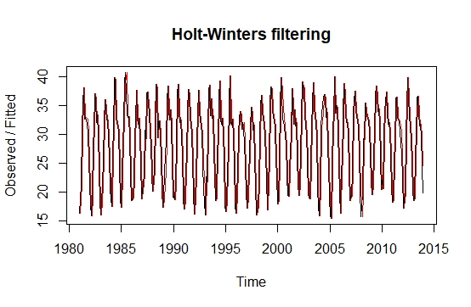

The plot shows the original time series in black, and the forecasts as a red line.

As a measure of the accuracy of the forecasts, we can calculate the sum of squared errors for the in-sample forecast errors, that is, the forecast errors for the time period covered by our

original time series. so we can get value of SSE,

[1] 7336.082.

That is, here the sum-of-squared-errors is 7336.082

By default HoltWinters() just makes forecasts for the time period covered by the original data. We can make forecasts for further time points by using the “forecast.HoltWinters()” function by giving first value in the time series as the initial value for the level.

### 1.1:- Forecasts from Simple Exponential Smoothing

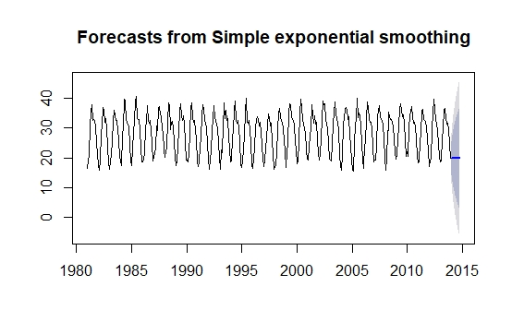

Here the forecasts for 2013-2015 are plotted as a blue line.

Now, to check whether the forecast errors are normally distributed with mean zero and constant variance. To check whether the forecast errors have constant variance, we can make a time plot of the in-sample forecast errors.

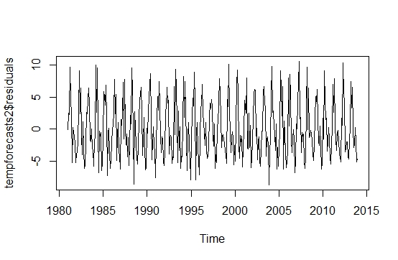**Graph_3:- Plot for In-Sample Forecast Error**

The plot shows that the in-sample forecast errors seem to have roughly constant variance over time, although the size of the fluctuations in the start of the time series may be slightly less than that at later dates.

To check whether the forecast errors are normally distributed with mean zero, we can plot a histogram of the forecast errors.

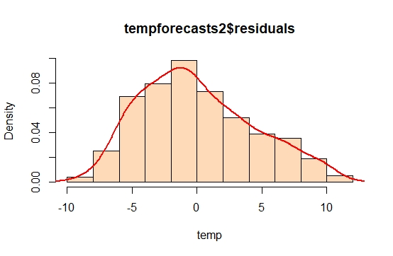**Graph_4:- Histogram of Forecast Errors**

The plot shows that the distribution of forecast errors is roughly centered on zero, and is more or less normally distributed.

# 2.Double Exponential Smoothing:-

If you have a time series that can be described using an additive model with increasing or decreasing trend and no seasonality, you can use Holt’s exponential smoothing to make short-term forecasts. Holt’s exponential smoothing estimates the level and slope at the current time point. Smoothing is controlled by two parameters, alpha, for the estimate of the level at the current time point, and beta for the estimate of the slope b of the trend component at the current time point. As with simple exponential smoothing, the parameters alpha and beta have values between 0 and 1, and values that are close to 0 mean that little weight is placed on the most recent observations when making forecasts of future values.

Now, we use Holt’s exponential smoothing to fit a predictive model for Temperature time series data using two parameters alpha and beta.

**HoltWinters Function Results for Double Exponential Smoothing:-**

|  |  |  |  |
| --- | --- | --- | --- |
| Smoothing parameters | Alpha | Beta | Gamma |
| 1 | 0.7106 | 0 |

Coefficients:[,1]

a 19.900000

b -4.517186

The estimated value of alpha 1, and of beta is 0.7106. These are both high, telling us that both the estimate of the current value of the level, and of the slope b of the trend component, are based mostly upon very recent observations in the time series.

The value of the sum-of-squared-errors for the in-sample forecast errors is 7573.072.

**Graph_5:-** **Plot Original Time Series against the Forecasts**

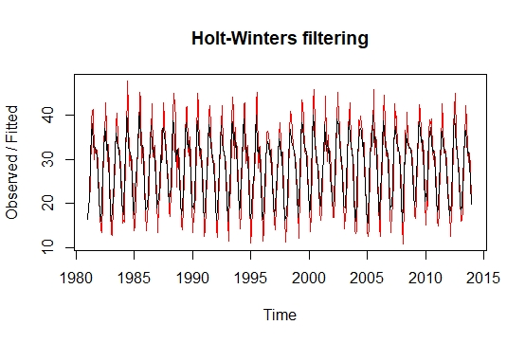

We plot the original time series as a black line, with the forecasted values as a red line. We can see from the picture that the in-sample forecasts agree pretty well with the observed values, although they tend to lag behind the observed values a little bit.

Now, we can make predictions for 2013 to 2015 and plot them.

### 2. Forecasts from Double Exponential Smoothing

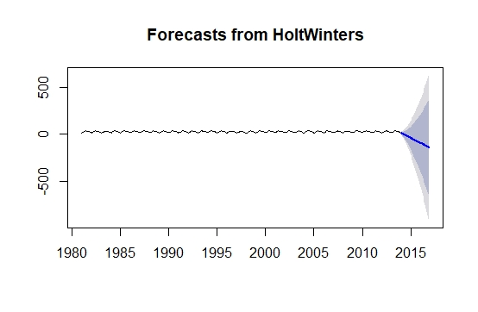

The forecasts are shown as a blue line.

# 3.Winter’s Exponential Smoothing:-

If you have a time series that can be described using an additive model with increasing or decreasing trend and seasonality, you can use Holt-Winters exponential smoothing to make short-term forecasts.

Holt-Winters exponential smoothing estimates the level, slope and seasonal component at the current time point. Smoothing is controlled by three parameters: alpha, beta, and gamma, for the estimates of the level, slope b of the trend component, and the seasonal component, respectively, at the current time point. The parameters alpha, beta and gamma all have values between 0 and 1, and values that are close to 0 mean that relatively little weight is placed on the most recent observations when making forecasts of future values.

To make forecasts, we can fit a predictive model using the HoltWinters() function for our data.

**HoltWinters Function Results for Winter’s Exponential Smoothing:-**

|  |  |  |  |
| --- | --- | --- | --- |
| **Smoothing parameters** | **Alpha** | **Beta** | **Gamma** |
| 0.1753 | 0.008964 | 0.2215 |

Coefficients: [,1]

a 27.179068613

b -0.008123107

|  |  |
| --- | --- |
| **Seasons** | |
| S1 | -9.69 |
| S2 | -8.36 |
| S3 | -2.45 |
| S4 | 2.97 |
| S5 | 8.32 |
| S6 | 9.71 |
| S7 | 6.59 |
| S8 | 4.88 |
| S9 | 4.48 |
| S10 | 2.47 |
| S11 | -2.41 |
| S12 | -7.37 |

The estimated values of alpha, beta and gamma are 0.17, 0.0086, and 0.2215, respectively. The value of alpha (0.17) is relatively low, indicating that the estimate of the level at the current time point is based upon both recent observations and some observations in the more distant past.

This makes good intuitive sense, as the level changes quite a bit over the time series, but the slope b of the trend component remains roughly the same.

As for simple exponential smoothing and Holt’s exponential smoothing, we can plot the original time series as a black line, with the forecasted values as a red line.

**Graph_6:-** **Plot Original Time Series against the Forecasts**

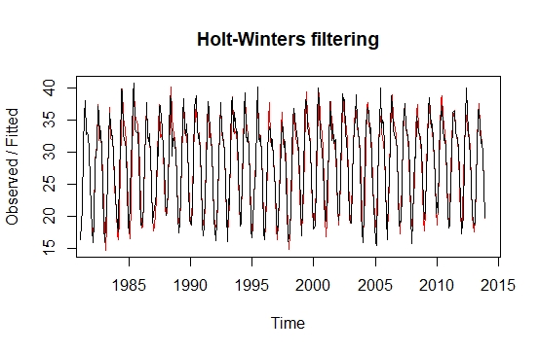

To make forecasts for future times not included in the original time series, we use the “forecast.HoltWinters()” function.

### 3.1:- Forecasts from Winter’s Exponential Smoothing

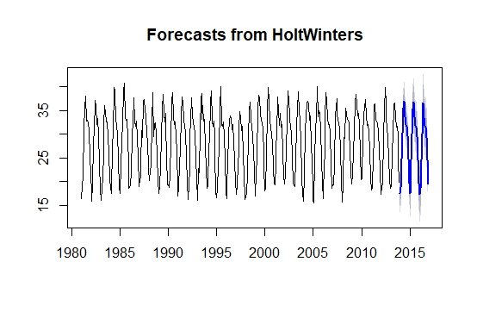

The forecasts are shown as a blue line.

**Conclusion:-**

Forecasting from winter’s exponential smoothing is the best forecasting.

# 4.AR Model:-

If current observations depends on previous observation then we can say that’s model is AR models. If current observation depends on first previous observation that’s model is called AR(1), if current observation depends on “2” previous observation that’s model is called AR(2) model and Similarly if current observation depend on “P” previous observation that’s model is called AR(P).

A process that depends upon the p lags is termed as AR (p) which has the following mathematical form

For selecting the best autoregressive model we use the Akaike and Schwarz information criteria. We select that model which contains the small value of the Akaike and Schwarz information criteria.

|  |  |  |
| --- | --- | --- |
| **Model** | **Akaike information criteria** | **Schwarz information criteria** |
| **AR(1)** | 2245.59 | 2234.56 |
| **AR(2)** | 2062.21 | 2201.65 |
| **AR(3)** | 2009.13 | 2156.65 |
| **AR(4)** | 1998.05 | 2023.78 |

From the above table of (AR Model) we select that model which has the smallest value of Akaike and Schwarz information criteria. It is clear that AR(4) has the smallest values so AR(4) model is best. So AR (4) is best model for future prediction.

# 5.MA Models:

If current error depends on previous error so we can say that’s model is called MA models. If current error depends on first previous error that’s model is called MA (1),and if current error depends on two previous error that’s model is called MA(2) model Similarly if current error depend on “q” previous error that’s model is called MA(q) Model.

A process that depends upon the q lags of the error terms is termed as MA (q).Which has the following mathematical form

Now we apply these processes on the series to find out the best model. .For selecting the best moving average model we use the Akaike and Schwarz information criteria. We select that model which contains the small value of the Akaike and Schwarz information criteria. The tables of the criteria and the estimated models are given below:

|  |  |  |
| --- | --- | --- |
| **MA Models** | **Akaike information criteria** | **Schwarz information criteria** |
| **MA(1)** | 2325.04 | 2259.02 |
| **MA(2)** | 2174.51 | 2199.76 |
| **MA(3)** | 2103.17 | 2165.65 |
| **MA(4)** | |  | | --- | | 2091.63 | | 2134.54 |

From the above table of (MA Model) we choose that model which has the smallest value of Akaike and Schwarz information criteria. It is clear that MA (4) has the smallest values so MA (4) model is best.So MA (4) model is best for future prediction.

# 6.ARMA Model

If current values depends on previous value and previous error so we can say that’s model is called ARMA models. If current value depends on first previous value and first previous error that’s model is called ARMA (1.1), and if current value depends on two previous value and two previous error that’s model is called ARMA(2,2) model Similarly if current valu depend on “q” previous error and “p” previous value that’s model is called ARMA(p,q) Model.

A process that depends upon the p lags of the series values and q lags of the error terms is termed as ARMA (p, q).

Now we apply these processes on the series to find out the best model. For selecting the best autoregressive Moving Average model, we use the Akaike and Schwarz information criteria. We select that model which contains the small value of the Akaike and Schwarz information criteria. The tables of the criteria and the estimated models are given below:

|  |  |  |
| --- | --- | --- |
| **ARMA Models** | **Akaike information criteria** | **Schwarz information criteria** |
| ARMA(1,1) | 2191.29 | 2243.65 |
| ARMA(1,2) | 2289.32 | 2267.44 |
| ARMA(1,3) | 2481.15 | 2635.43 |
| ARMA(1,4) | 2803.95 | 2954.221 |

From the above table of (ARMA Model) we choose that model which has the smallest value of Akaike and Schwarz information criteria. It is clear that ARMA (1,1). has the smallest values so ARMA (1,1). model is best. So ARMA (1,1). is best model for future prediction.

# 7.Overall Decision:

Now finally we will suggest the more appropriate model among all of them which we selected earlier as AR (4), MA (4) and ARMA (1,1) by using Akaike information criteria (AIC) and Schwarz Bayesians information criteria (BIC).

|  |  |  |
| --- | --- | --- |
| **Models** | **Akaike information criteria** | **Schwarz information criteria** |
| **AR(4)** | 1998.05 | 2023.78 |
| **MA(4)** | 2091.63 | 2134.54 |
| **ARMA(1,1)** | 2191.29 | 2243.65 |

# 8.Fit the AR(4) model:-

For a given time series we can fit the autoregressive (AR) model using the arima() command and setting order equal to c(4, 0, 0). Note for reference that an AR model is an ARIMA(4, 0, 0) model.

**AR(4,0,0) Model Results**

Coefficients:

ar1 ar2 ar3 ar4 intercept

0.9934 -0.1799 -0.1699 -0.1812 28.3261

s.e. 0.0494 0.0699 0.0700 0.0497 0.2776

sigma^2 estimated as 8.768: log likelihood = -993.02, aic = 1998.05

now we plotted the series along with fitted values.

**Graph_7:-**

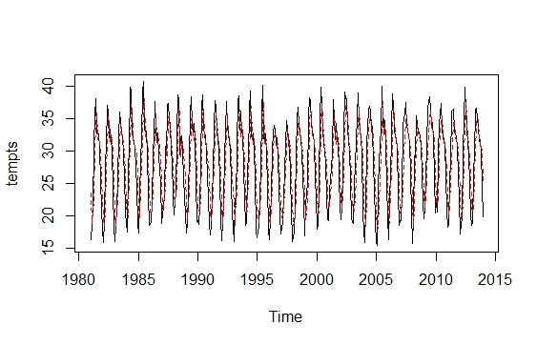

### 8.1Forecasting using AR(4) model:-

The predict() function can be used to make forecasts from an estimated AR model.

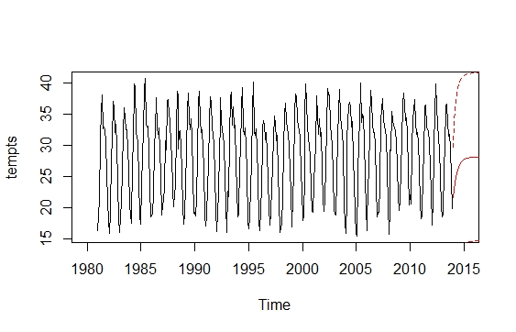We can forecast 30 values from 2014 to 2016 and plot them.

# 9.MA(4) model:-

We can fit the simple moving average (MA) model using arima (…, order = c(0, 0, 4)). Note for reference that an MA model is an ARIMA(0, 0, 4) model.

**MA(0,0,4) Model Results**

Coefficients:

ma1 ma2 ma3 ma4 intercept

1.1758 1.0565 0.5989 0.1860 28.2457

s.e. 0.0496 0.0659 0.0608 0.0488 0.6709

sigma^2 estimated as 11.13: log likelihood = -1039.82, aic = 2091.63

Now we plot series along with fitted values.

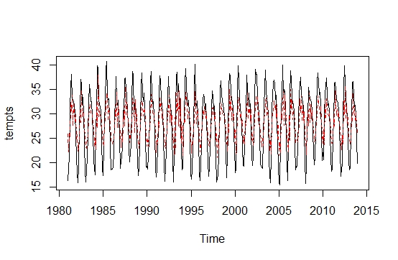**Graph_8:-**

### 9.1Forecasting using MA model:-

We can forecast 30 values from 2014 to 2016 and plot them.

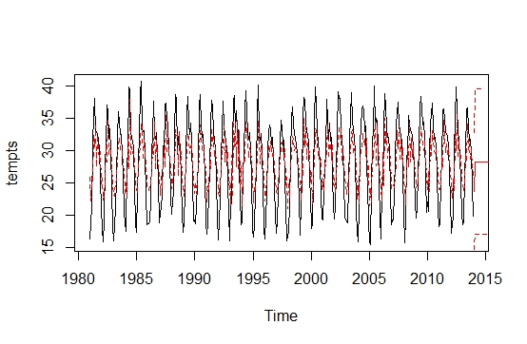

# 10.ARMA(1,1) Model:-

For a given time series we can fit the ARIMA(1,1) model using the arima() command and setting order equal to c(1, 1). Note for reference that an ARIMA model is an ARIMA(1, 1) model.

**ARMA(1,1) Model Results**

arima(x = tempts, order = c(1, 1))

Coefficients:

ar1

0.4465

s.e. 0.0450

sigma^2 estimated as 14.86: log likelihood = -1093.64, aic = 2191.29

Now we plot series along with fitted values.

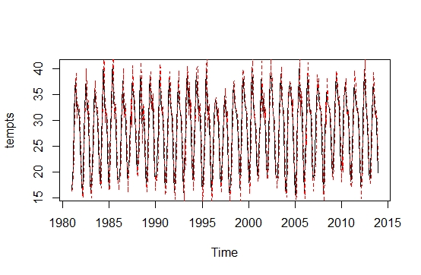**Graph_9:-**

### 10.1Forecasting using ARMA model:-

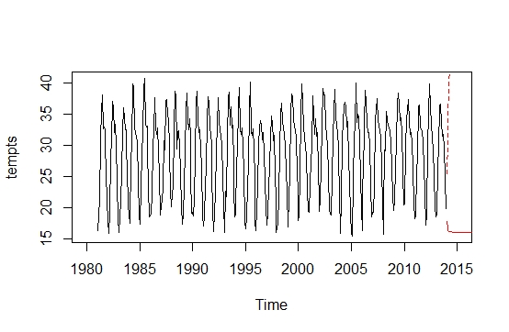We can forecast 30 values from 2014 to 2016 and plot them.

# 11.SARMA (p, q)(P ,Q)12:

Aseasonally differenced process that depends upon the p lags of the series values and q lags of the error terms is termed as SARMA (p, q)12. Now we apply these processes on the series to find out the best model. For selecting the best autoregressive Moving Average model, we use the Akaike and Schwarz information criteria. We select that model which contains the small value of the Akaike and Schwarz information criteria. The tables of the criteria and the estimated models are given below:

|  |  |  |
| --- | --- | --- |
| **Model** | **AIC** | **BIC** |
| **SARMA(1,1) (1,1)12** | 1604.37 | 1854.53 |
| **SARMA(2,1) (2,1)12** | 1736.34 | 1943.64 |
| **SARMA(2,2) (2,2)12** | 1865.43 | 2075.53 |
| **SARMA(3,1)(3,1)12** | 1976.65 | 2135.76 |

In above statement we discuss that **SARMA(1,1)(1,1)12**) is best model because its AIC and BIC values are smallest in the table. So the model is **SARMA(1,1)(1,1)12.**

# 12.Fit the SARMA(1,1)(1,1)12 Model:-

For a given time series we can fit the SARMA(1,1)(1,1)12 model.

**SARMA(1,1)(1,1)12 Model Results:-**

arima(x = tempts, order = c(0, 1, 1), seasonal = list(order = c(1, 1, 1), period = 12))

Coefficients:

ma1 sar1 sma1

-0.7896 0.0318 -0.9368

s.e. 0.0545 0.0562 0.0367

sigma^2 estimated as 3.539: log likelihood = -798.18, aic = 1604.37

Now we plot series along with fitted values.

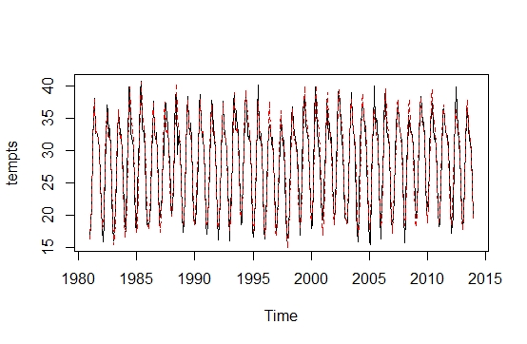**Graph_10:-**

### 12.1Forecasting using SARMA Model:-

